Sarah I. Jones

1980

Ellie Daniels Moro 2008

Mello Mitchell 2017

Rylan Moro 2004 2004

Liam Moro 2000

*Fred Harold Daniels*

Jonah S.K. Knowles

2015

Justice J.K. Knowles

2019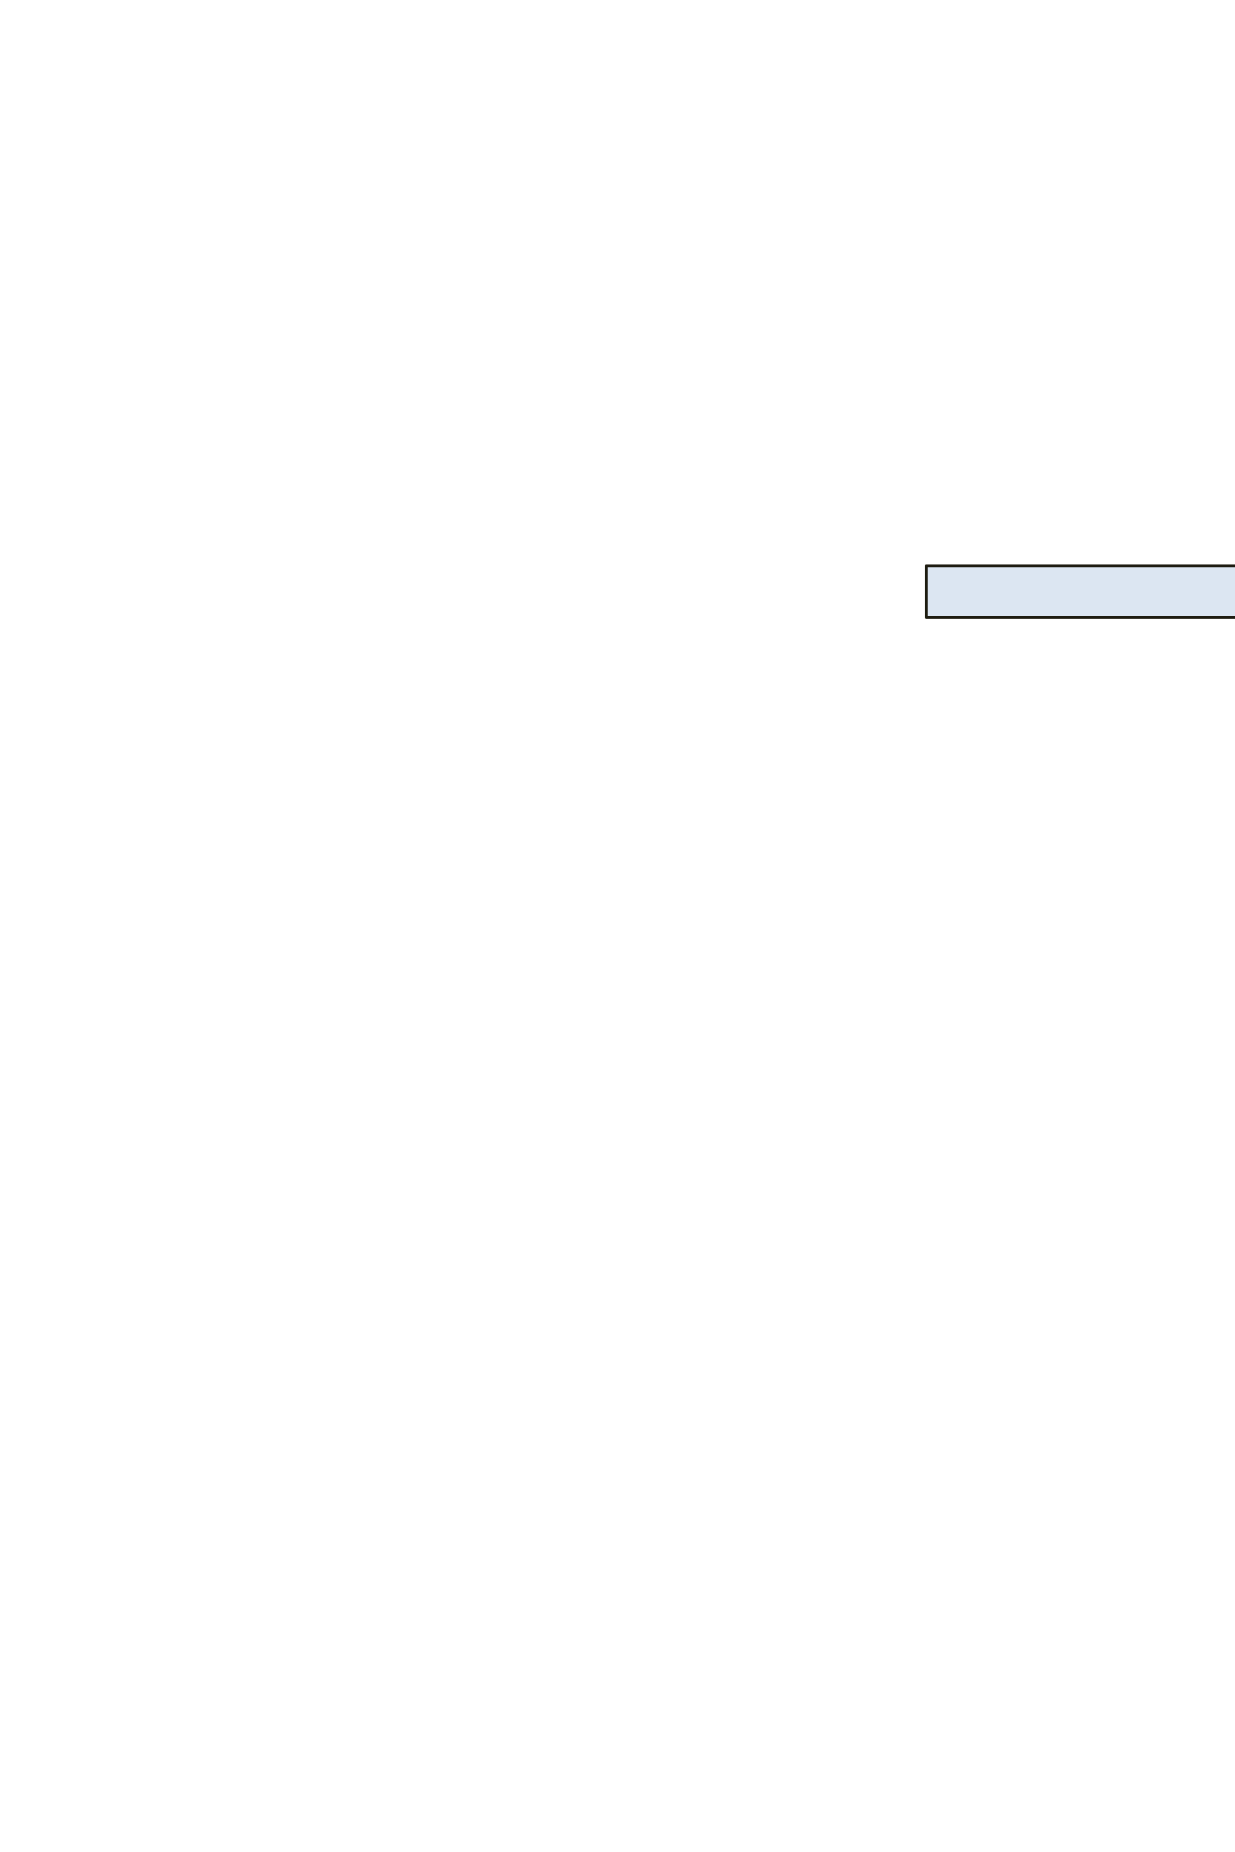

Jerman J.K.Knowles

2014

Camryn G. Newton

2016

Greyson J. Newton 2014

Julie Daniels Key

1991

Caroline Bronson Key 1989

Amy Daniels Bronson

1956

m. Wayne R. Key

Peter Bronson 1953

m. Ornella F. Mattera

Bruce Goddard Daniels

1924

m. Janet Beach

Eleanor Daniels

1917

m. Samuel Bronson

m. Stuart Hodge

Dezzi L. Daniels 2008

Susan Jeanelle Ott 1985

m. Thomas E. Merritt

Heather Daniels 1978

m. Charles Mitchell

Dylan D. Cook 1980

Tucker B. Daniels 1984

Sarah Elizabeth Ott 1981

m. Scott C. Carlin

Timothy L. Morse 1980

m. Lindsey Brandt

Nathaniel G. Morse 1978

m. Courtney A. Scannell

James T. Morse 1975

James Harvey Smith 2012

Austin D. Merritt 2016

Ashley D. Merritt 2011

Julia Grace Carlin 2009

Carlos Sebastian LaHoz Daniels

1984

Martha Beach Daniels

1957

m. Ezra Kreamer

Fred Harold Daniels

1955

m. Christine Carey

Eleanor Goddard Daniels 1953

m. Donna Broderick

Josiah K. Davis 2018

Jayla Ryan 2012

Margaret Daniels 1993

Rachel Shelly Ott 1984

Jessica Daniels 1987

Judith Daniels 1951

m. Stanley Ott

Sarah Daniels 1950

m. Harvey Morse

Fred Harold Daniels

1887

m. Eleanor Grace Goddard